  
  
  
Digital Password Locking System for Door in LabVIEW

Project Title: Digital Password Locking System for Door in LabVIEW

Institution: Suresh Gyan Vihar University

Submitted To - Dr. Sandhya Sharma (HOD of 1st year Engineering)

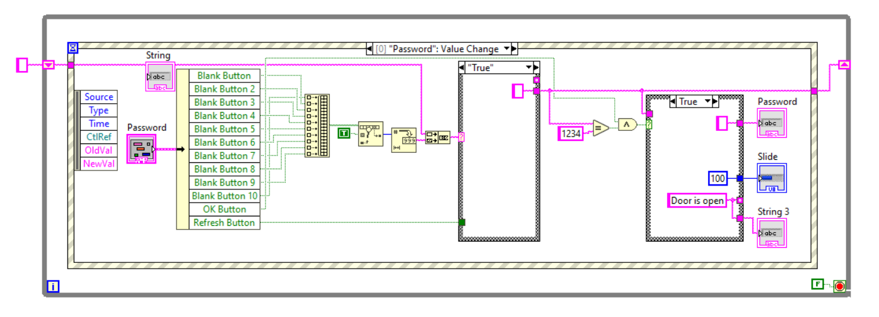

# Table of Contents

1. Abstract

2. Introduction

3. Project Requirements and Tools Used

4. System Design and Development

4.1 Password Input Interface

4.2 Password Verification Process

4.3 Gate Mechanism and Indicators

5. Program Flow

6. Event Structure and Case Structure Explanation

7. Functionality Testing and Results

8. Use Case Diagram

9. Challenges Faced and Solutions Implemented

10. Conclusion

# 1. Abstract

This project presents a digital password locking system designed in LabVIEW software. The system incorporates a graphical interface for password input and verification. Utilizing 12 buttons, event structures, and case structures, the program checks a user-entered 4-digit password against a preset password. If the password matches, a virtual gate represented by a slider opens, and an indication message appears. This report details the design, testing, an functionality of the project.

# 2. Introduction

The Digital Password Locking System is designed as a secure access control mechanism built in LabVIEW. The system simulates a scenario where access to a restricted area, like a gate or door, is granted only when the correct password is entered. It’s intended as a foundational model of password-based security systems that could be applied in offices, homes, or laboratories. The primary goal is to create an interface that allows users to securely enter a password and access the locked area only if the password is correct.

**LabVIEW, which stands for Laboratory Virtual Instrument Engineering Workbench**, is used widely for designing and controlling systems in both industrial and research environments. This graphical programming platform allows users to build systems through a visual, drag-and-drop approach that is ideal for creating real-time control systems and interactive user interfaces. By using LabVIEW, this project leverages its flexibility to create an event-driven control system that’s both responsive and functional. LabVIEW’s extensive library provides tools such as loops, event handling, and logical operators that allow for a highly interactive user interface. For example, this project uses a while loop to ensure continuous operation, event structures to respond to user inputs, and case structures to handle different scenarios, such as entering a password or clearing the screen.

The main objective of this project is to provide a secure yet simple interface where users can enter a 4-digit password, which will be verified against a preset code. The system emphasizes security by ensuring access is granted only if the correct password is entered. Visual indicators also make the system user-friendly by providing feedback to confirm access is either granted or denied. To make the interaction simple and straightforward, the interface includes numeric buttons labeled 0 to 9 for entering the password, a clear button for resetting the input if a mistake is made, and an OK button to confirm the password entry. When the correct password is entered, a slider representing the gate opens, and a text message confirms that access is granted. If the password is incorrect, the user can press the clear button to reset and try again.

The project emphasizes security and simplicity. On the security side, only those who know the password can gain access, simulating a real-world password-protected locking mechanism. The user experience is kept straightforward by providing immediate feedback for actions taken (for example, messages for successful or unsuccessful entry and responses to incorrect entries). This design is adaptable, meaning that the system could incorporate additional security features in the future, such as advanced authentication methods or layered security protocols.

# 3. Project Requirements and Tools Used

The project was developed in LabVIEW, utilizing various graphical programming tools and structures.

Requirements:

**- LabVIEW software (version)**

LabVIEW software provides the graphical environment where this password locking system was created. It supports the use of drag-and-drop components, control loops, and logical structures that make it especially useful for designing control and automation systems.

**Components Used:**

**- 12 Button Interface (numbers 0-9, Clear, and OK)**

The 12-button interface includes numbers 0 to 9, a clear button, and an OK button. These buttons serve as the user input mechanism. Each button, representing numbers 0 through 9, is used to enter digits of the password. The clear button resets any current input, and the OK button submits the password for verification. Together, these buttons form a simple interface for user interaction.

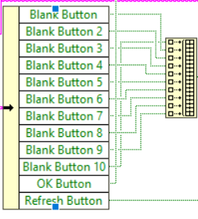

**- While Loop**

The while loop enables continuous operation of the program, ensuring that the system remains active and responsive to button presses until a specific condition, such as pressing a stop button, is met. This loop allows the program to check for user input repeatedly, making the system dynamic and responsive.

**- Event Structure**

The event structure captures button press events, meaning it waits for a user to interact with any of the buttons. When an event is detected, the system processes the button press. This structure helps control the user interface and makes the program efficient by responding only when a button is pressed.

**- Case Structure**

The case structure is used to define different program states, such as when a password digit is entered, when clear is pressed, or when OK is pressed to submit the password. Each case executes specific logic depending on which button was pressed, allowing for organized handling of each input event.

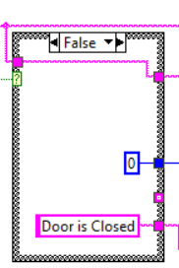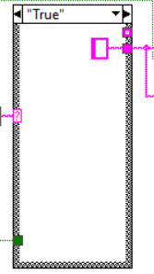

**- Build Array Function**

The build array function collects each entered digit in sequence, creating an array of numbers that represent the password input by the user. This array holds the four digits of the password entered by the user, which will later be checked against the preset password.

**- Decimal to Binary Converter**

The decimal to binary converter is used to convert the numeric input into a binary format when needed, supporting different data handling processes in LabVIEW. This component is helpful for transforming user input into a format that is more compatible with the comparator or logical functions, depending on specific LabVIEW requirements.

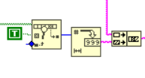

**- AND Gate**

The AND gate is used in combination with the OK button, making sure that the password input process is complete before the entered digits are checked. The AND gate confirms that only when the OK button is pressed should the system proceed to validate the password.

**- Comparator**

The comparator checks if the entered password matches the preset password. This comparison step is the core of the password verification process. If the entered password matches the preset, the system will allow access by opening the gate, while a mismatch results in denied access.

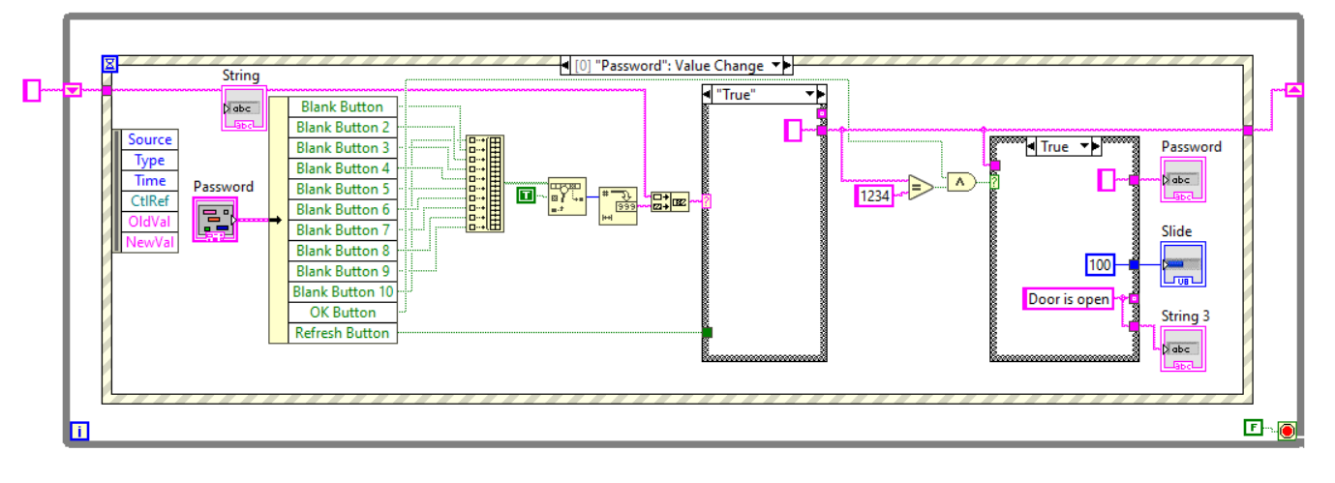

# 4. System Design and Development

## 4.1 Password Input Interface

The system’s user interface consists of 10 buttons for numbers (0-9), a Clear button, and an OK button. Each button press appends the corresponding digit to an array, building a 4-digit password. The Build Array function collects each digit entry sequentially.

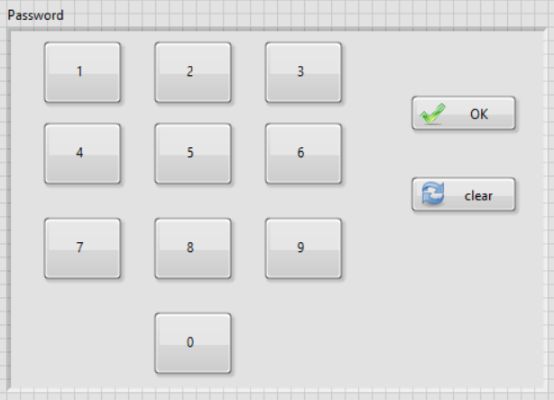

## 4.2 Password Verification Process

Upon pressing OK, the AND gate verifies if the input is complete. A comparator then checks if the entered 4-digit password matches the preset password. If matched, the system opens the gate.

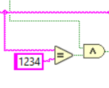

## 4.3 Gate Mechanism and Indicators

The gate is represented by a slider. When the password matches, the slider moves to indicate the gate is open, and a text display shows 'Gate Opened.' If Clear is pressed, the gate closes and displays 'Gate Closed.'

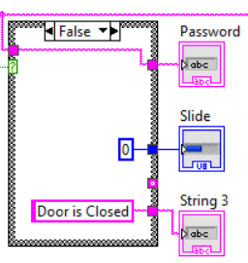

# 5. Program Flow

The program flow begins with

**User input - > Password verification - > A Gate Response.**

The While loop and event structure handle continuous operation and response to button events.

# 6. Event Structure and Case Structure Explanation

Event structure captures button press events and directs them to specific actions. Case structure handles cases such as Password Entry and Clear. Each case defines a unique functionality in the system.

# 7. Functionality Testing and Results

Various test cases were conducted, including correct password entry, incorrect password entry, and password clearing. Screenshots and observations for each case are documented.

# 8. Use Case Diagram

The following use case diagram displays user actions (e.g., Enter Password, Press OK, Press Clear) and system responses.

# 9. Challenges Faced and Solutions Implemented

# During the development of this password-locking system, several challenges arose, particularly in synchronizing button events and handling multiple cases effectively. LabVIEW's event-driven structure requires precise timing and response to user interactions, especially in systems where multiple buttons and events are triggered simultaneously. For instance, in this system, each button press had to be carefully coordinated to ensure that digits were correctly added to the password array and that actions like resetting the input or confirming the password were executed in the right sequence. Without proper synchronization, there was a risk of incorrect inputs being processed or actions being triggered prematurely, leading to unreliable or confusing outcomes for the user.

# One of the primary issues was ensuring that the program responded correctly to each button press, especially when users interacted with multiple buttons in quick succession. Each button, whether a number, clear, or OK, needed to execute its specific function without affecting other parts of the system. For example, pressing clear should reset the input without interfering with any previously entered numbers, while pressing OK should trigger password validation only if all four digits have been entered. This required a well-defined event logic that could manage simultaneous interactions while ensuring that each button action was handled in isolation.

# To address these challenges, the event logic was refined to separate each button press into distinct cases that executed independently of one another. By carefully configuring each event and ensuring each button’s action was processed one at a time, the system was able to reliably track inputs and respond accurately. Each case within the event structure was programmed to perform only its designated task, such as adding a digit to the array or resetting it, without interrupting or overlapping with other cases. This systematic approach helped streamline the flow of actions, ensuring that each function was performed as expected and providing users with a clear and reliable interface for secure password entry.

# 10. Conclusion

This project successfully implemented a secure password-locking mechanism using LabVIEW. By designing a system that requires a correct 4-digit password for access, it simulates a fundamental model of door security. The project’s structure allowed for a user-friendly interface where individuals can enter their passwords through clearly labeled numeric buttons and receive immediate feedback on whether access was granted. This setup demonstrates an effective balance of simplicity and security, making it a practical prototype for real-world applications.

One of the strengths of the system is its responsiveness and accuracy in distinguishing between correct and incorrect password entries. This ensures reliable access control, as the gate only opens when the exact password matches the preset code. The design also prevents any security gaps by using clear functionality for the buttons, including a reset feature to clear incorrect entries and an OK button to verify the password. These controls make the system both intuitive and secure, showing how LabVIEW can be used effectively in security-focused applications.

For future improvements, the system could be enhanced with additional security features, such as limiting the number of allowed attempts. This would further secure the system by triggering an alert or temporary lockout after multiple incorrect attempts, preventing unauthorized access. Other potential upgrades might include adding two-factor authentication or integrating a biometric component for more advanced security layers. By implementing these future enhancements, this LabVIEW-based system could evolve into a highly robust security solution adaptable for various secure access scenarios.